INDEX NUMBER: 4201020

Name: Azu Joshua

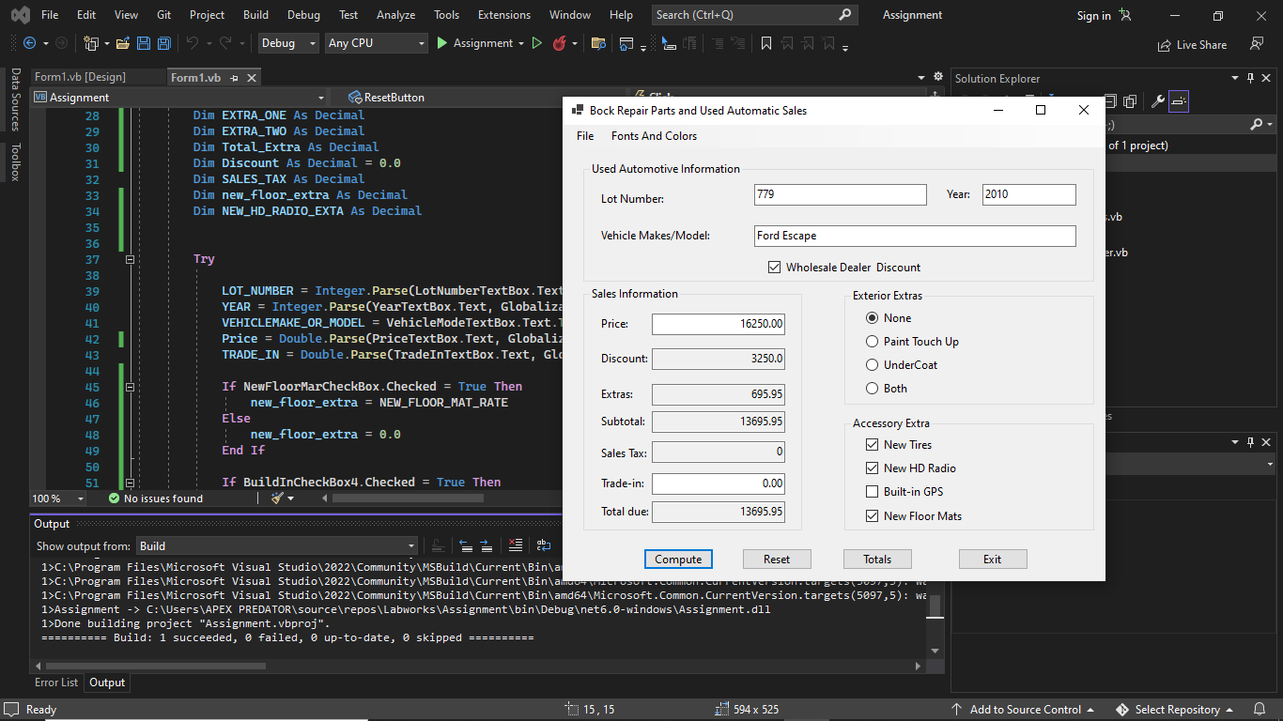

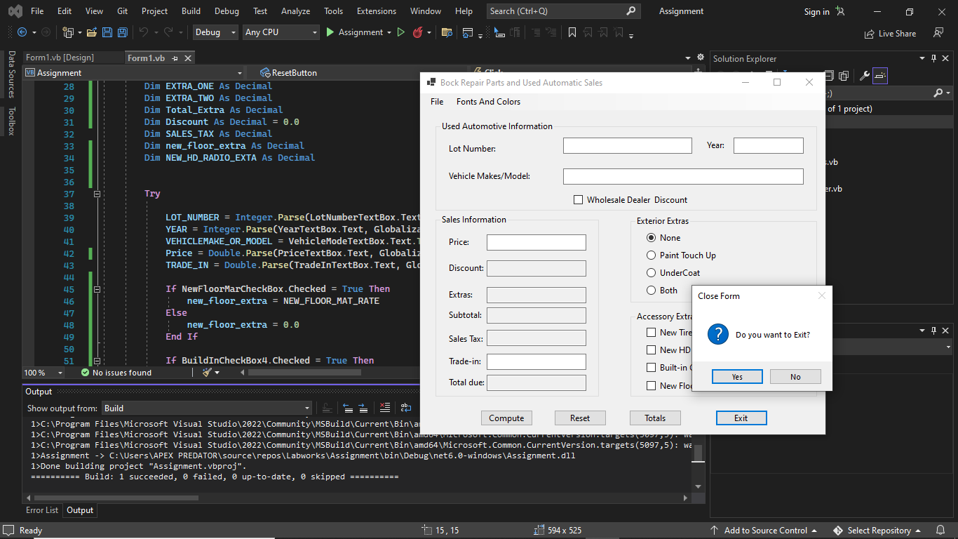

Public Class Form1

Const SALES_TAX As Decimal = 0.05D

Const PAINT_TOUCH_UP_EXTERIOR As Decimal = 250D

Const Under_Coat_Extra As Decimal = 300D

Const Both_UnderCoat_Paint As Decimal = 550D

Dim New_TIRES As Decimal = 450D

Dim NEW_HD_RADIO_RATE As Decimal = 190.95D

Dim BUILT_IN_GPS_RATE As Decimal = 700D

Dim NEW_FLOOR_MAT_RATE As Decimal = 55D

Dim VehicleCount_RATE As Integer = 0

Dim TotalSales_RATE As Decimal = 0

Dim AVERAGE_RATE As Decimal

Dim TOTAL_DUE As Decimal

Const WHOLESALEDISCOUNT As Decimal = 0.2D

Private Sub ComputeButton_Click(sender As Object, e As EventArgs) Handles ComputeButton.Click

'Declaring of Variables

Dim Sub_Total As Decimal

Dim LOT_NUMBER As Integer

Dim YEAR As Integer

Dim VEHICLEMAKE_OR_MODEL As String

Dim Price As Integer

Dim TRADE_IN As Decimal

Dim BUILT_IN_GPS As Decimal

Dim NEW_TIRE_EXTRA As Decimal

Dim EXTRA_ONE As Decimal

Dim EXTRA_TWO As Decimal

Dim Total_Extra As Decimal

Dim Discount As Decimal = 0.0

Dim SALES_TAX As Decimal

Dim new_floor_extra As Decimal

Dim NEW_HD_RADIO_EXTA As Decimal

Try

LOT_NUMBER = Integer.Parse(LotNumberTextBox.Text, Globalization.NumberStyles.Integer)

YEAR = Integer.Parse(YearTextBox.Text, Globalization.NumberStyles.Number)

VEHICLEMAKE_OR_MODEL = VehicleModeTextBox.Text.ToString

Price = Double.Parse(PriceTextBox.Text, Globalization.NumberStyles.Currency)

TRADE_IN = Double.Parse(TradeInTextBox.Text, Globalization.NumberStyles.Currency)

If NewFloorMarCheckBox.Checked = True Then

new_floor_extra = NEW_FLOOR_MAT_RATE

Else

new_floor_extra = 0.0

End If

If BuildInCheckBox4.Checked = True Then

BUILT_IN_GPS = BUILT_IN_GPS_RATE

Else

BUILT_IN_GPS = 0.0

End If

If NewTiresCheckBox.Checked = True Then

NEW_TIRE_EXTRA = New_TIRES

Else

NEW_TIRE_EXTRA = 0.0

End If

If HDCheckBox.Checked = True Then

NEW_HD_RADIO_EXTA = NEW_HD_RADIO_RATE

Else

NEW_HD_RADIO_EXTA = 0.0

End If

If Whole_Sale_checkBox.Checked = True Then

Discount = Price * WHOLESALEDISCOUNT

EXTRA_ONE = new_floor_extra + NEW_TIRE_EXTRA + BUILT_IN_GPS + NEW_HD_RADIO_EXTA

Sub_Total = Price + EXTRA_ONE - Discount

SALES_TAX = 0.0

Else

Sub_Total = Price + new_floor_extra + NEW_TIRE_EXTRA + BUILT_IN_GPS + NEW_HD_RADIO_EXTA

End If

If PaintUpRadioButton.Checked = True Then

Sub_Total += PAINT_TOUCH_UP_EXTERIOR

EXTRA_TWO = PAINT_TOUCH_UP_EXTERIOR

ElseIf UnderCoatRadioButton.Checked = True Then

Sub_Total += Under_Coat_Extra

EXTRA_TWO = Under_Coat_Extra

ElseIf BothRadioButton.Checked = True Then

Sub_Total += Both_UnderCoat_Paint

EXTRA_TWO = Both_UnderCoat_Paint

Else

Sub_Total += 0.0

EXTRA_TWO = 0.0

End If

If Whole_Sale_checkBox.Checked = True Then

SALES_TAX = 0.0

Else

SALES_TAX = Sub_Total * SALES_TAX

End If

TOTAL_DUE = Sub_Total + SALES_TAX - TRADE_IN

Total_Extra = EXTRA_ONE + EXTRA_TWO

Discount_TextBox.Text = Discount.ToString

Extra_TextBox.Text = Total_Extra.ToString

SubTotal_TextBox.Text = Sub_Total.ToString

SalesTextBox.Text = SALES_TAX.ToString

TotalDueTextBox.Text = TOTAL_DUE.ToString

Catch ex As MissingFieldException

MessageBox.Show("Please ensure all fields Has been Field")

Catch ex As FormatException

If IsNumeric(PriceTextBox.Text) = False Or PriceTextBox.Text = "" Then

MessageBox.Show("Please check Price Text Box")

End If

If YearTextBox.Text = "" Then

MessageBox.Show("Please INPUT YEAR")

End If

Catch ex As Exception

MessageBox.Show("Please an error occur" & ex.ToString)

End Try

End Sub

Private Sub Form1_Load(sender As Object, e As EventArgs) Handles MyBase.Load

End Sub

Private Sub ColorsToolStripMenuItem_Click(sender As Object, e As EventArgs) Handles ColorsToolStripMenuItem.Click

ColorDialog1.Color = Me.BackColor

ColorDialog1.ShowDialog()

Me.BackColor = ColorDialog1.Color

End Sub

Private Sub FontsToolStripMenuItem_Click(sender As Object, e As EventArgs) Handles FontsToolStripMenuItem.Click

FontDialog1.Font = Me.Font

FontDialog1.ShowDialog()

Me.Font = FontDialog1.Font

End Sub

Private Sub ExitButton_Click(sender As Object, e As EventArgs) Handles ExitButton.Click

Dim Message As String = "Do you want to Exit?"

If MessageBox.Show(Message, "Close Form", MessageBoxButtons.YesNo, MessageBoxIcon.Question) = Windows.Forms.DialogResult.Yes Then

Me.Close()

End If

End Sub

Private Sub ExitToolStripMenuItem_Click(sender As Object, e As EventArgs) Handles ExitToolStripMenuItem.Click

ExitButton.PerformClick()

End Sub

Private Sub ComputeToolStripMenuItem_Click(sender As Object, e As EventArgs) Handles ComputeToolStripMenuItem.Click

ComputeButton.PerformClick()

End Sub

Private Sub ResetButton_Click(sender As Object, e As EventArgs) Handles ResetButton.Click

If TOTAL_DUE <> 0 Then

VehicleCount_RATE += 1

TotalSales_RATE += TOTAL_DUE

AVERAGE_RATE = TotalSales_RATE / VehicleCount_RATE

End If

TOTAL_DUE = 0.0

LotNumberTextBox.Clear()

VehicleModeTextBox.Clear()

YearTextBox.Clear()

PriceTextBox.Clear()

Whole_Sale_checkBox.Checked = False

Discount_TextBox.Clear()

Extra_TextBox.Clear()

SubTotal_TextBox.Clear()

SalesTextBox.Clear()

TotalDueTextBox.Clear()

TradeInTextBox.Clear()

PaintUpRadioButton.Checked = False

NoneRadioButton.Checked = True

UnderCoatRadioButton.Checked = False

BothRadioButton.Checked = False

NewTiresCheckBox.Checked = False

HDCheckBox.Checked = False

NewFloorMarCheckBox.Checked = False

BuildInCheckBox4.Checked = False

End Sub

Private Sub ResetToolStripMenuItem_Click(sender As Object, e As EventArgs) Handles ResetToolStripMenuItem.Click

ResetButton.PerformClick()

End Sub

Private Sub TotalButton_Click(sender As Object, e As EventArgs) Handles TotalButton.Click

If VehicleCount_RATE = 0 And TotalSales_RATE = 0 Then

Dim Message = "No Vehicle has been sold yet"

MessageBox.Show(Message, "Zero Sales Averages", MessageBoxButtons.OK, MessageBoxIcon.Information)

Else

Dim Message =

MessageBox.Show("Total due all sales: $" & TotalSales_RATE.ToString & ControlChars.NewLine & "Total vehicle sold:" & VehicleCount_RATE & ControlChars.NewLine & "Average total due: $" & AVERAGE_RATE.ToString & MessageBoxIcon.Information, "Totals and Average")

End If

End Sub

Private Sub TotalsToolStripMenuItem_Click(sender As Object, e As EventArgs) Handles TotalsToolStripMenuItem.Click

TotalButton.PerformClick()

End Sub

End Class